LAB 1 – IS
21K-3278
Sohaib Sarosh Shamsi
Task 1:
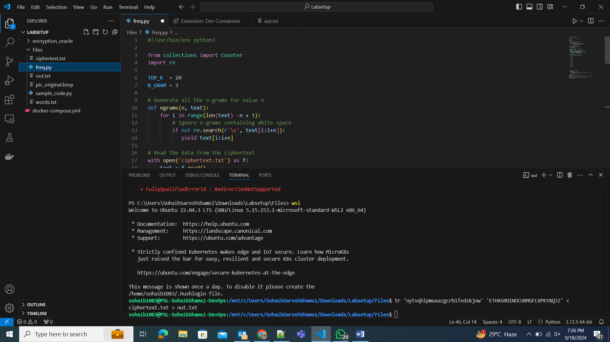
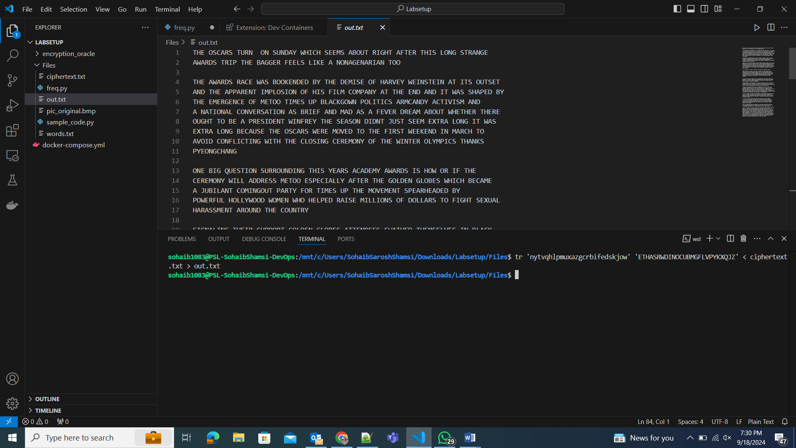
I ran the frequency.py file which gave us an idea of the frequency distribution of the ciphertext.txt file. Using this we were able to find the common substitutions and start working out the key. The result was:
nytvqhlpmuxazgcrbifedskjow (cipher text) = ETHASRWDINOCUBMGFLVPYKXQJZ (plain text)
Using this key, we were able to decrypt the cipher text.

Task 2:
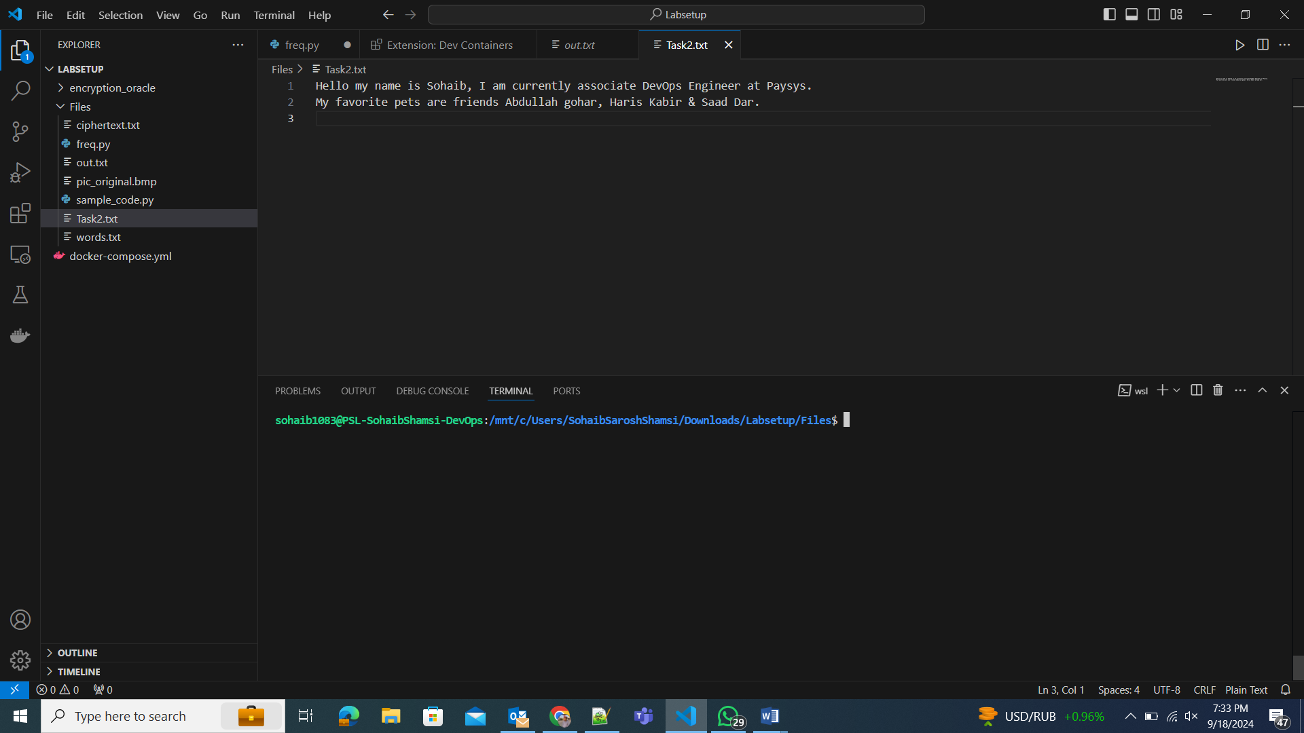
We used the openssl command line tool to encrypt the text using the aes-128-cbc cipher and saving the output in aes-128-cbc.txt
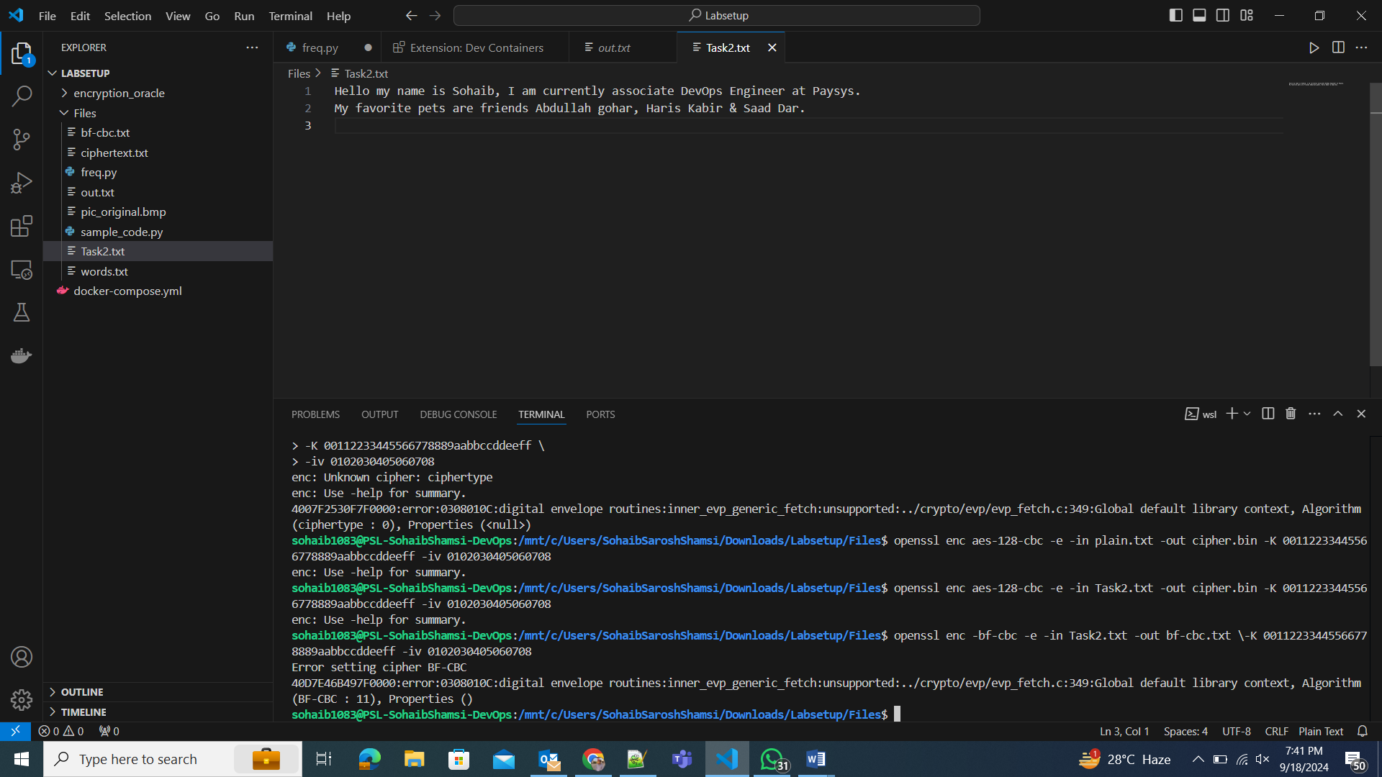
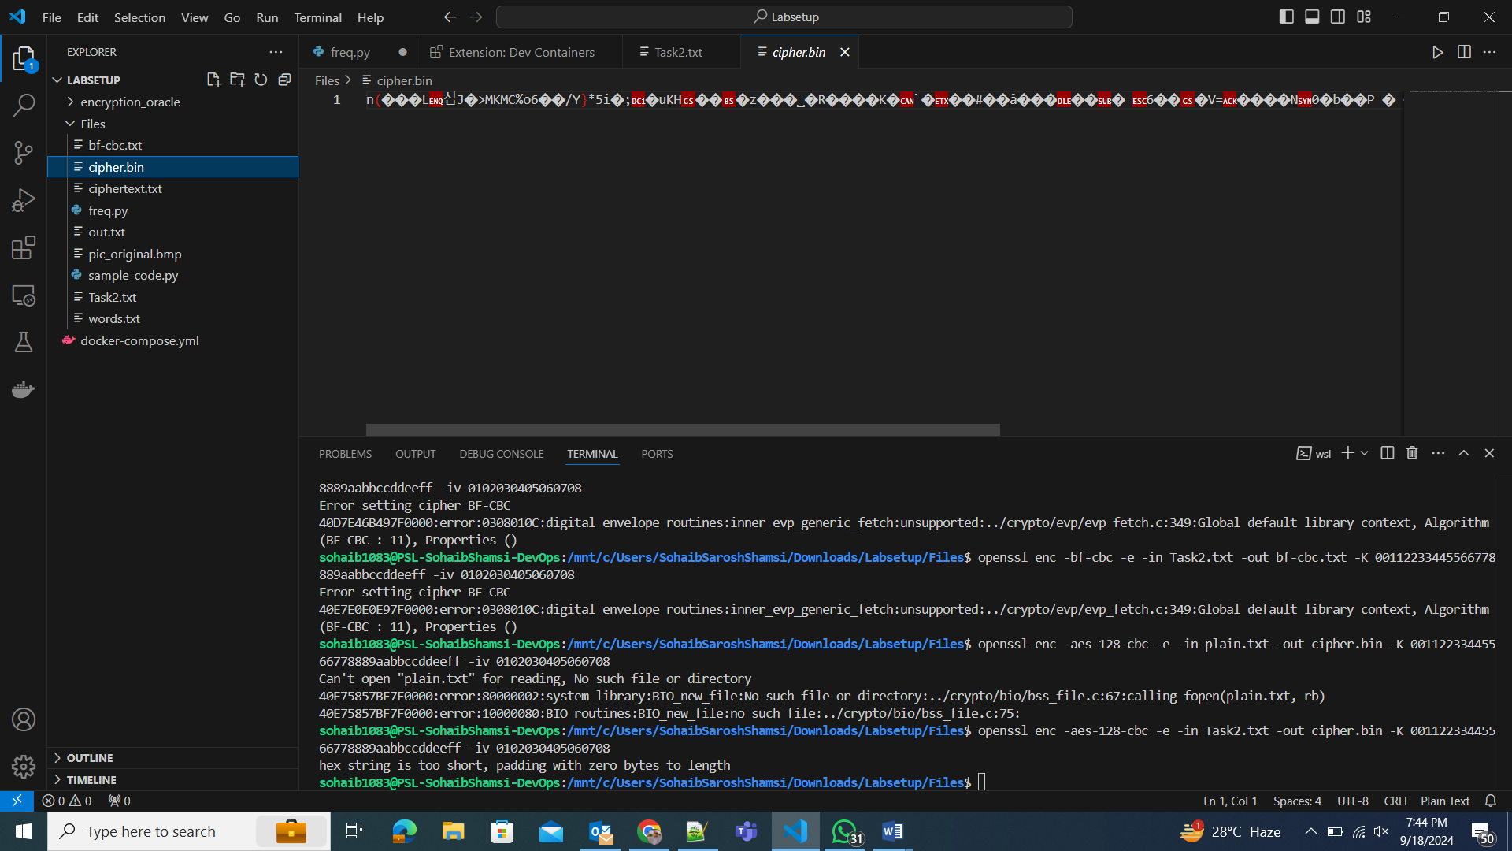
Task 3:
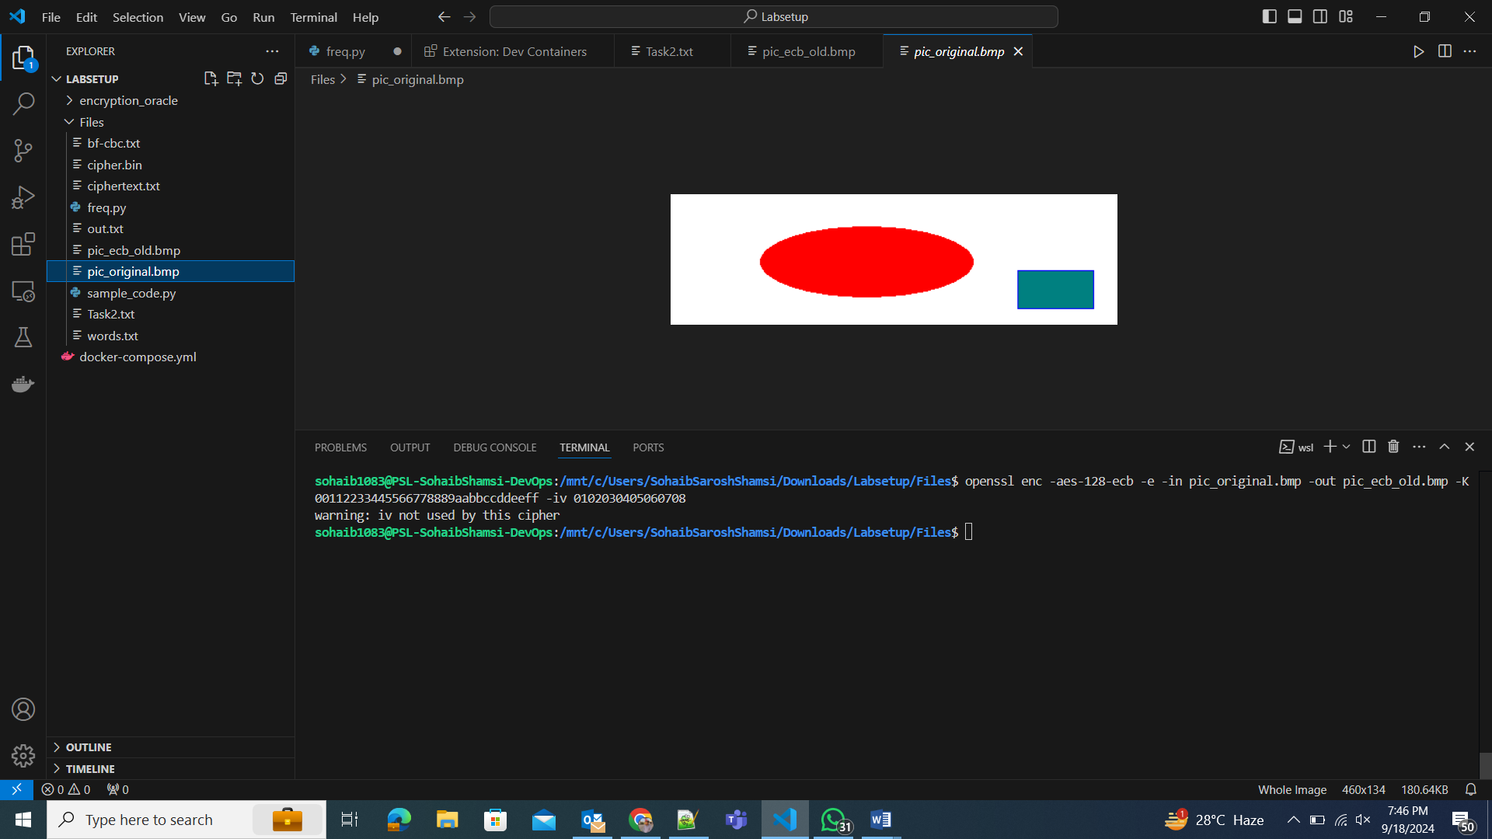
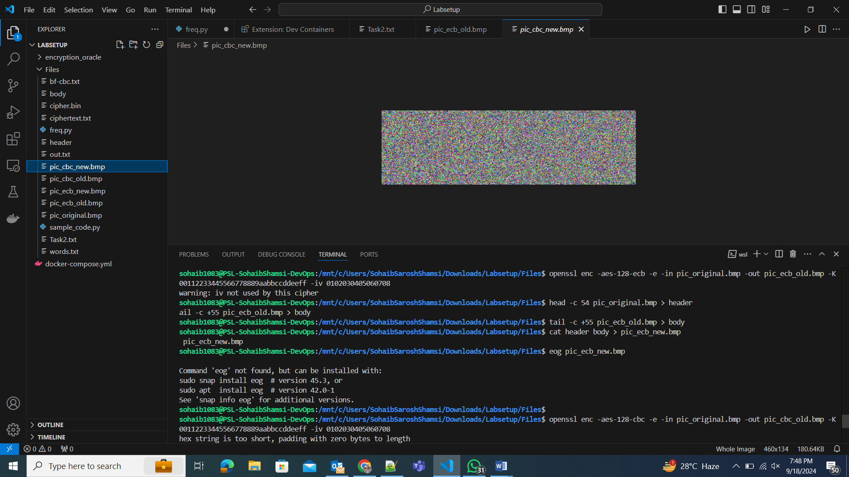
Task 4:
Modes that require padding are ECB and CBC
These modes operate on fixed-size blocks (e.g., 128 bits for AES), so padding is needed if the data is not a multiple of the block size.
Modes that do not require padding CFB and OFB
These modes behave like stream ciphers, processing data in smaller units (bits or bytes), so they can handle any size of input without needing padding.
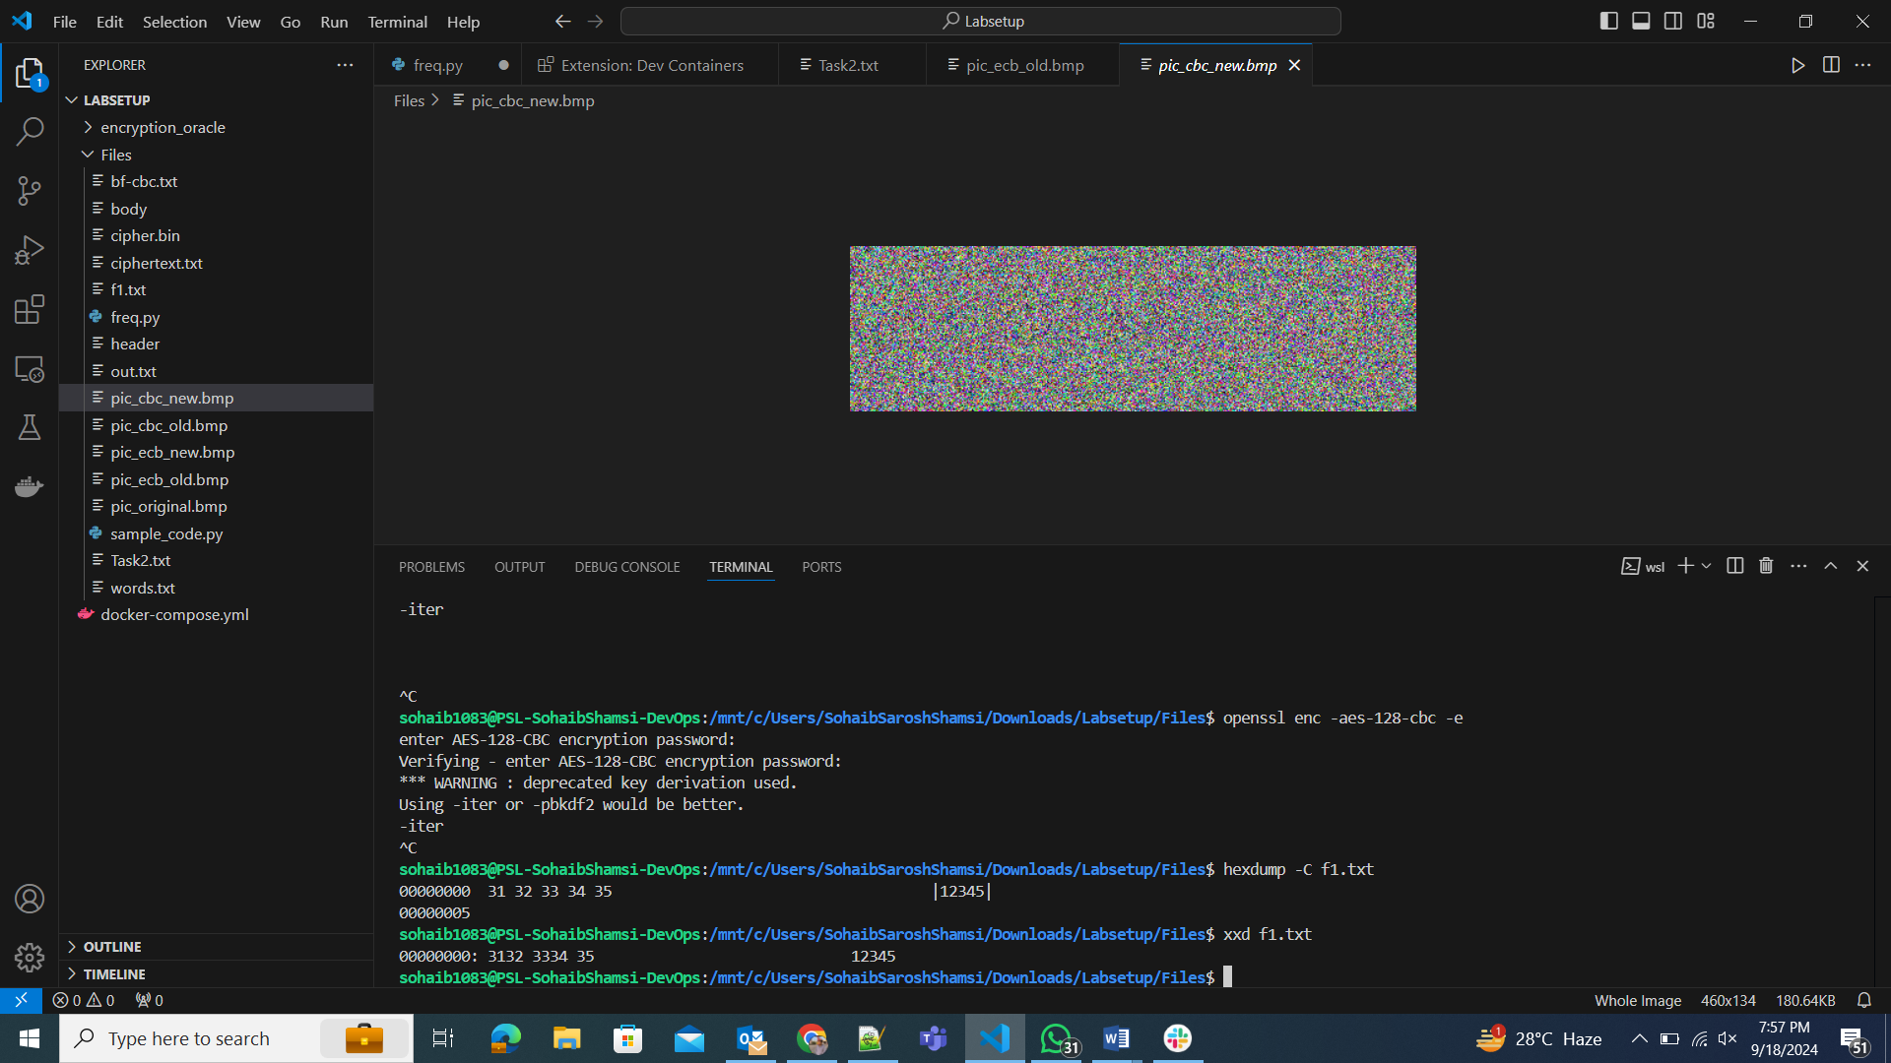

Task 5:
In ECB and OFB independent block processing makes both encryption and decryption parallelizable. We can assume that most of the plaintext will be recovered except for the corrupted block.
In CBC and CFB we can decrypt the data in parallel, but it is not possible when encrypting data. Thus, we can assume that only the plaintext before the corrupted block will be recovered.
ECB
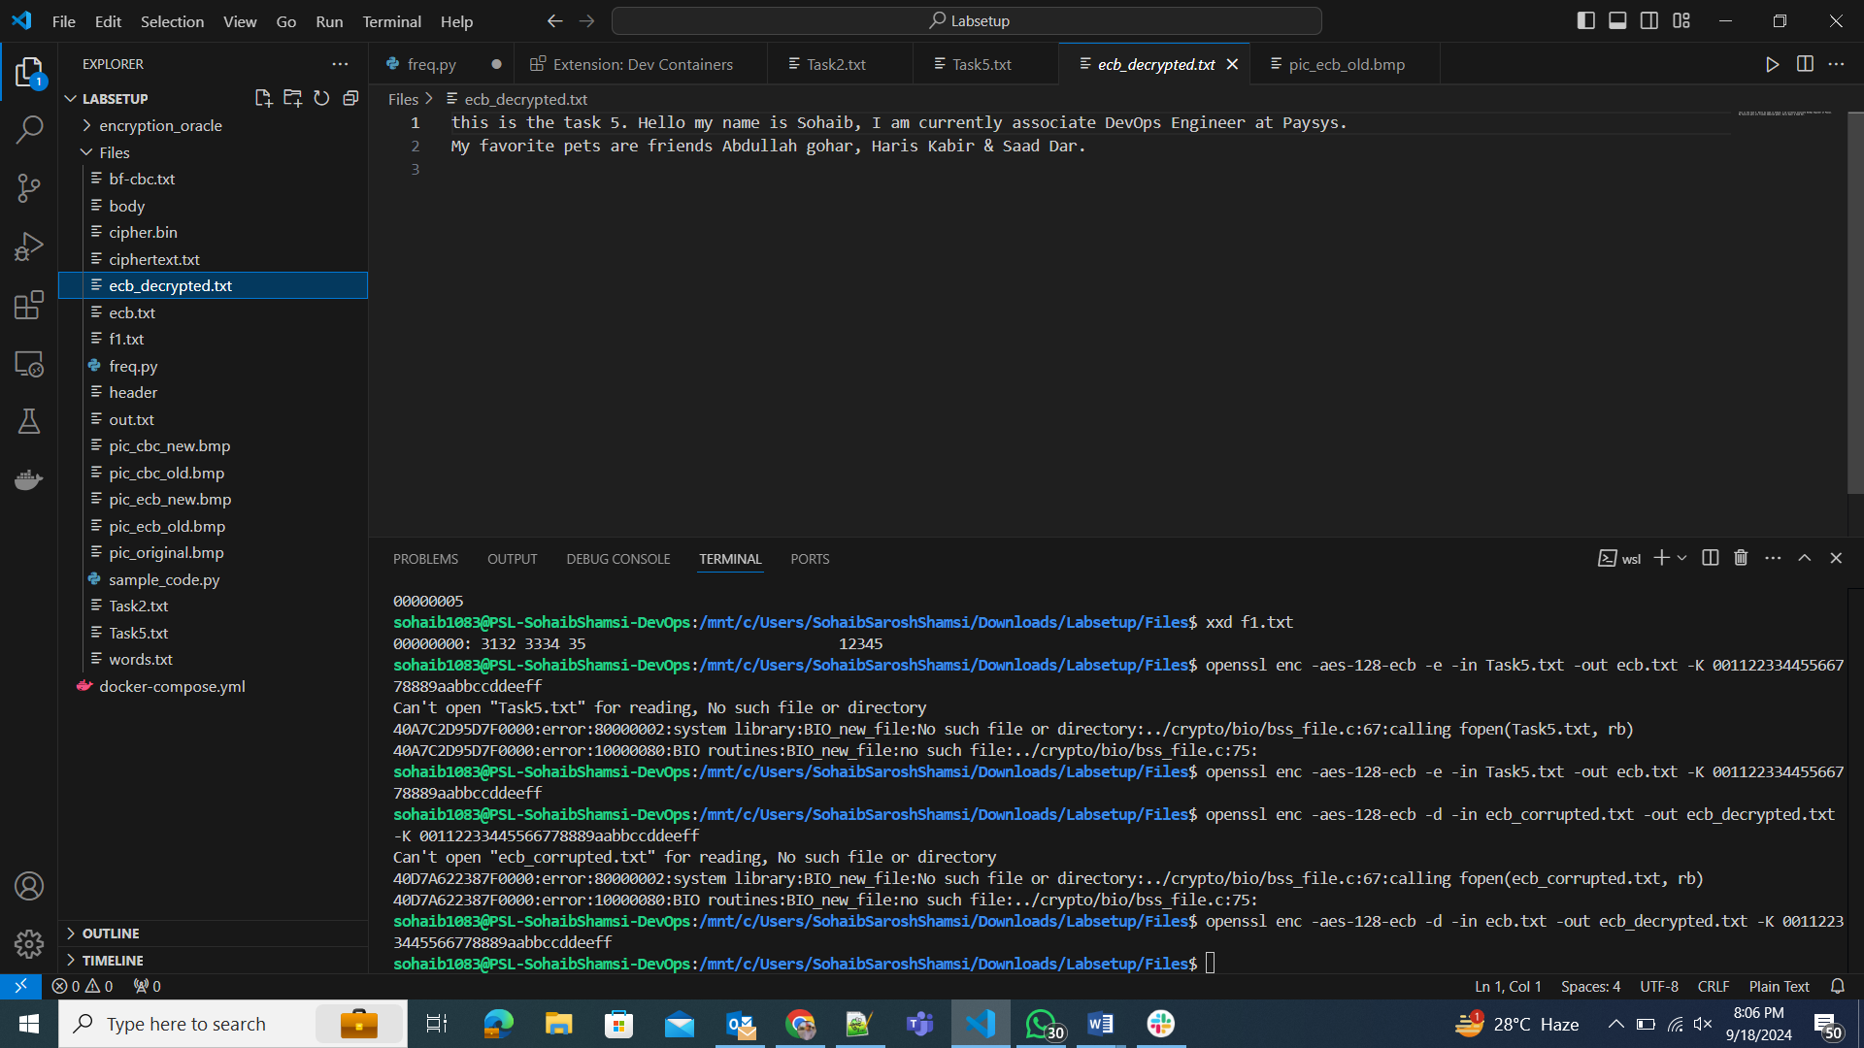
CBC:
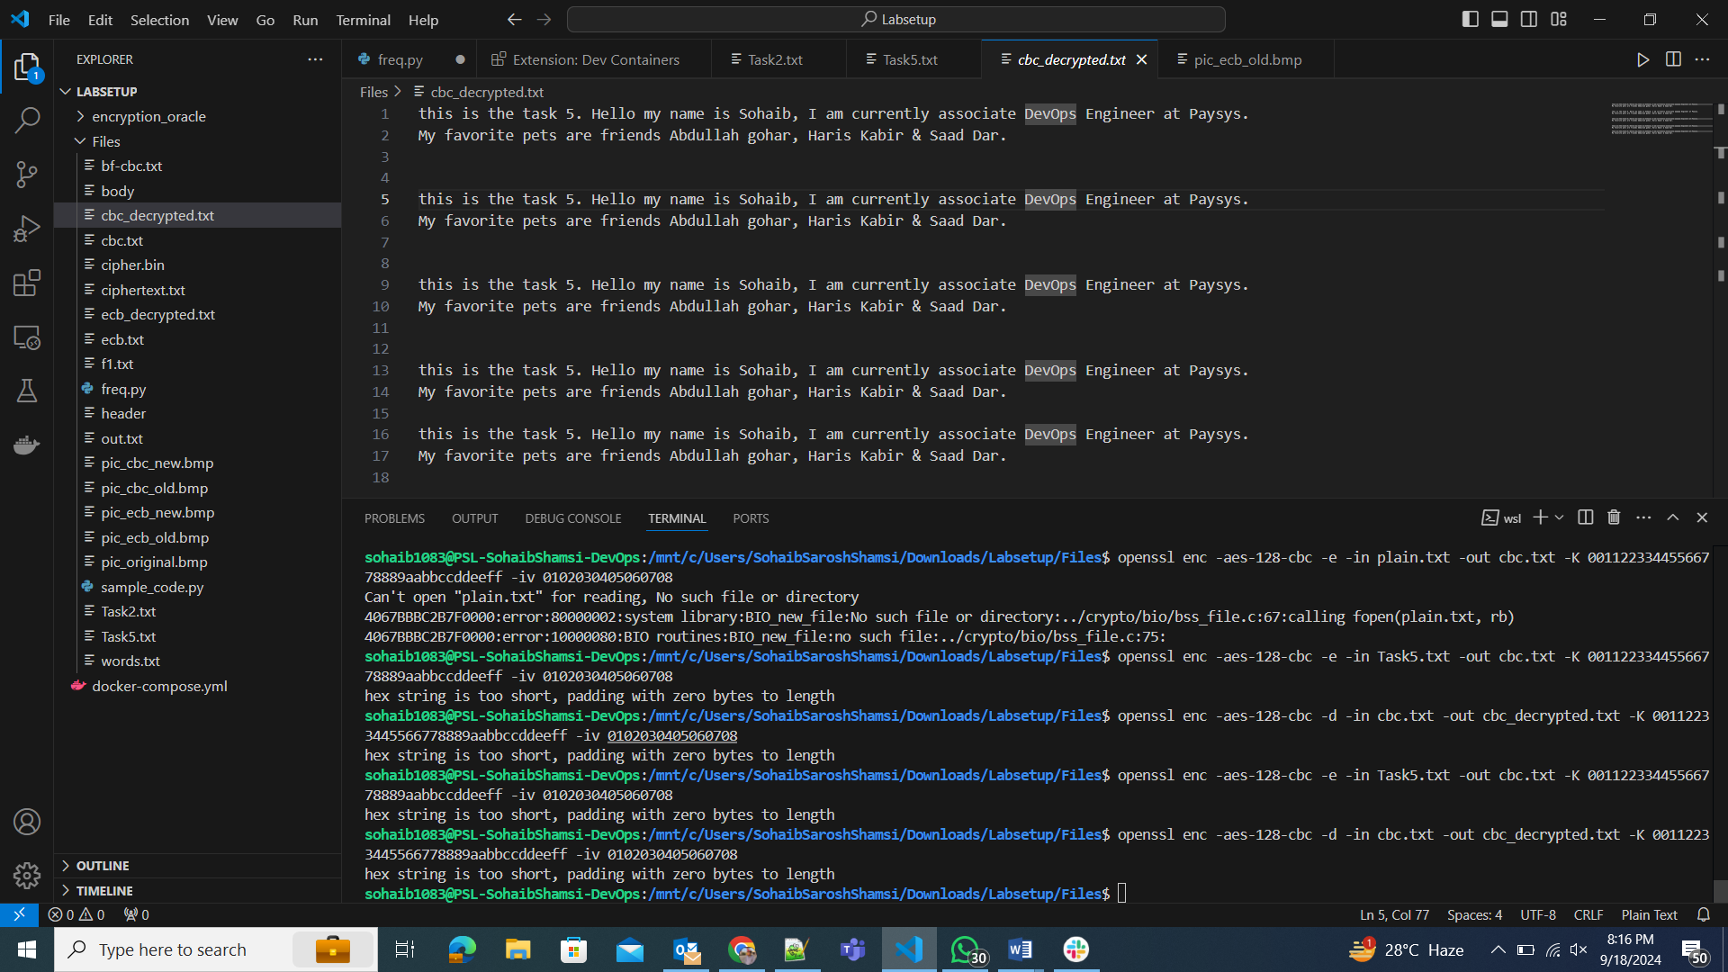
CFB:
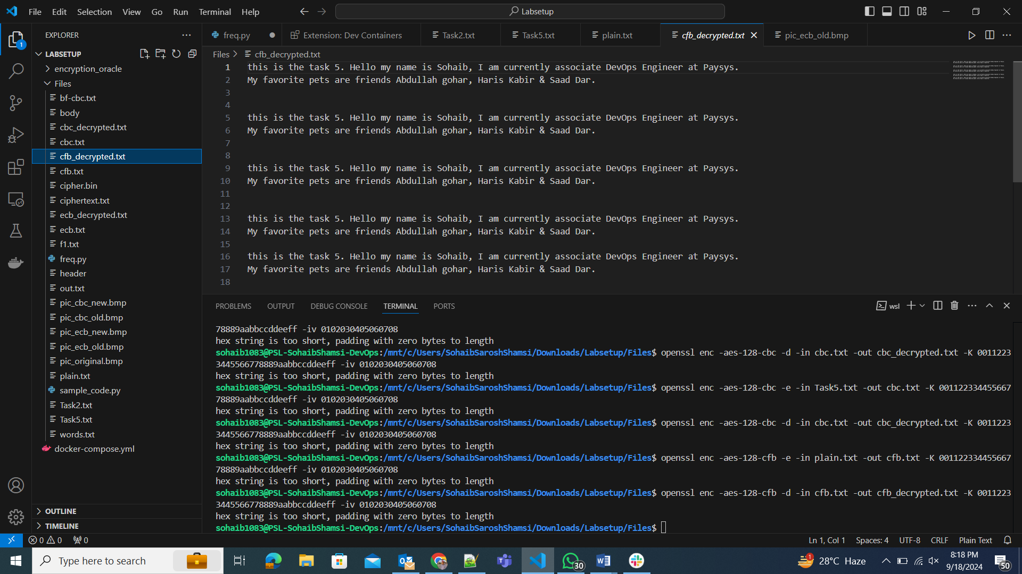

Task 6:
Two different IVs and the same IVs:
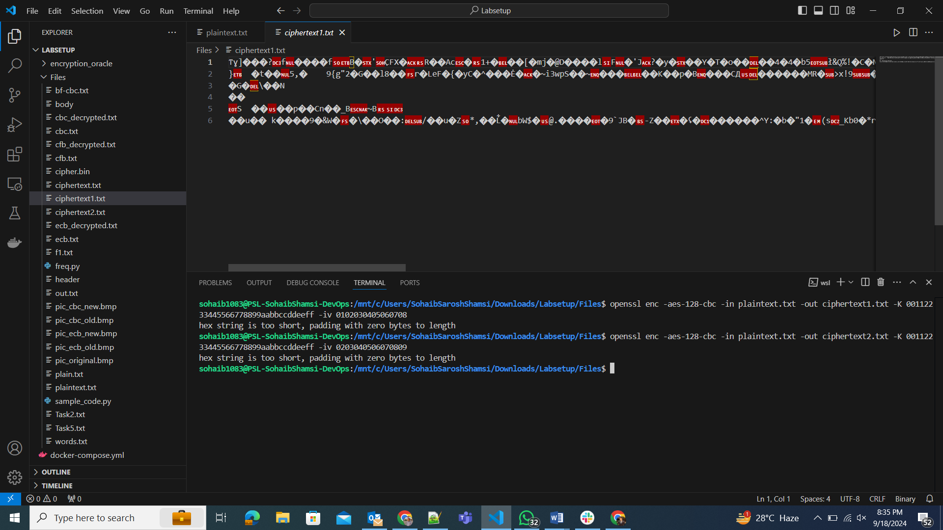
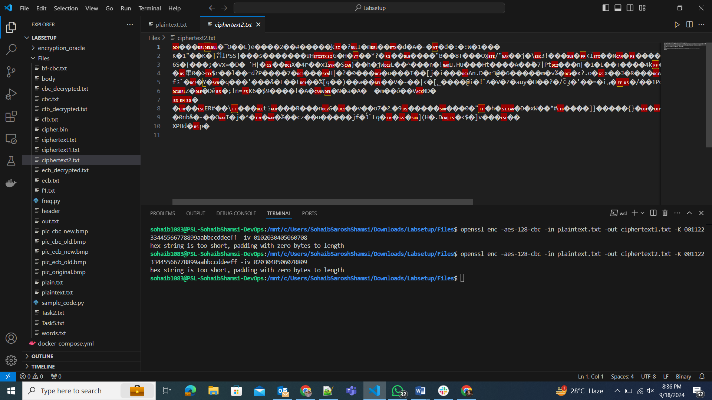
• When you encrypt the same plaintext with the same key but different IVs, the resulting ciphertexts are different, as IVs introduce randomness.
• Using the same IV twice reduces the security of the encryption, as the same plaintext and key combination will produce identical ciphertexts.
• OFB Mode: If the same IV and key are reused, an attacker can recover the plaintext by XORing the known plaintext with the ciphertext.
• CFB Mode: This applies to the first block of the ciphertext, where plaintext can be recovered, but the remaining blocks stay secure unless the key is leaked.
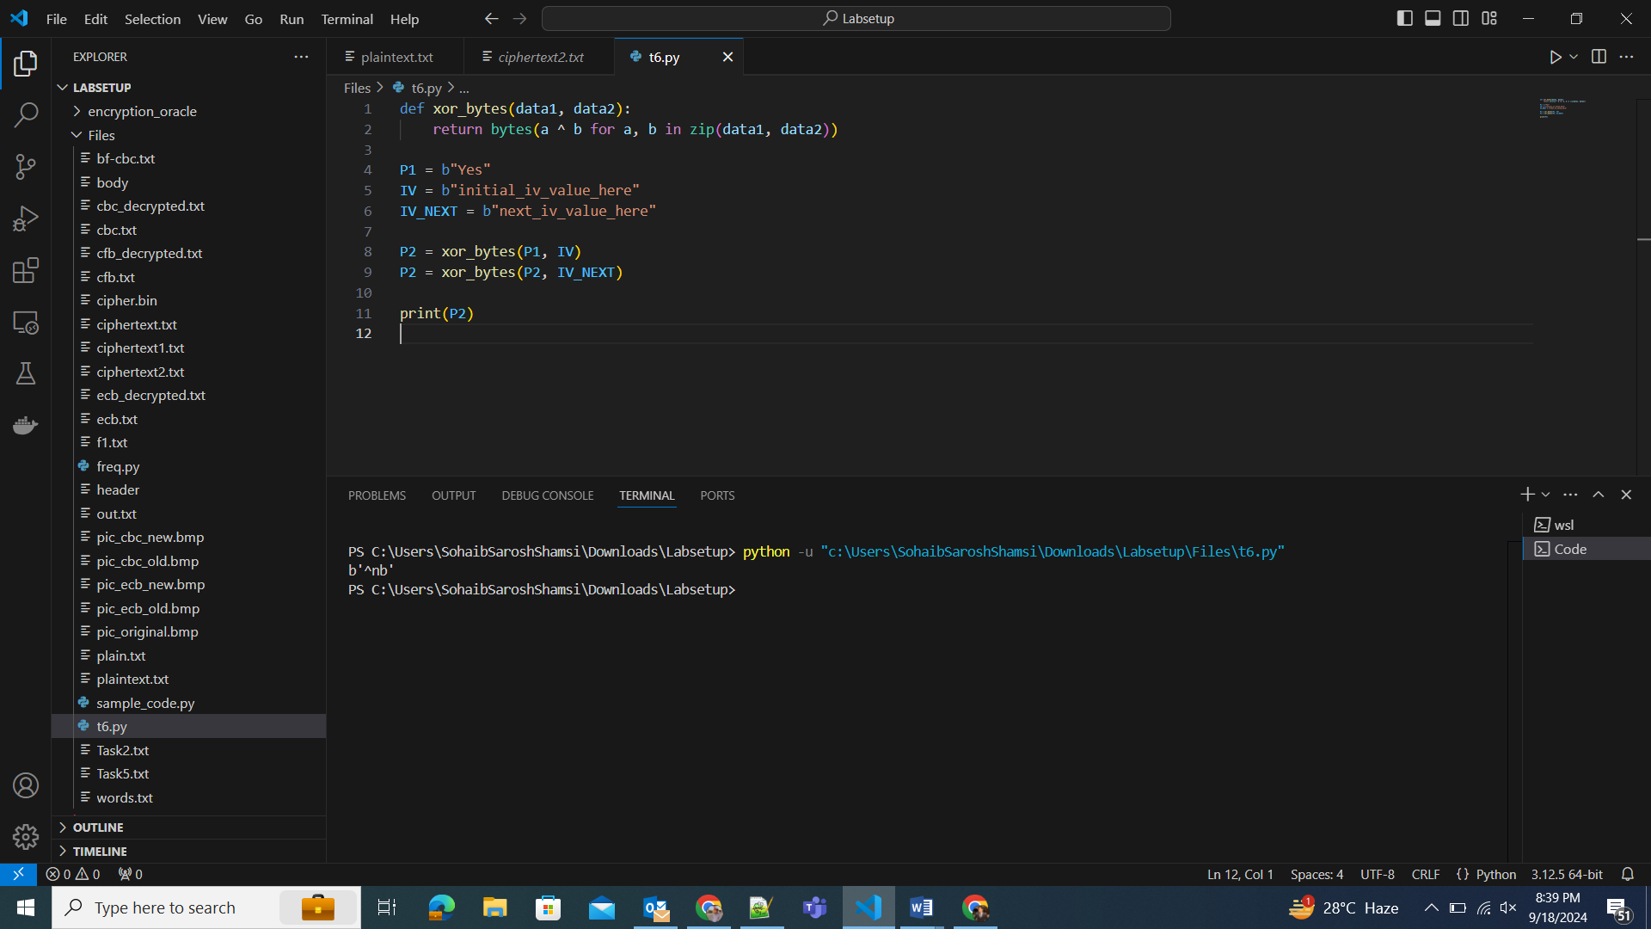
6.2:
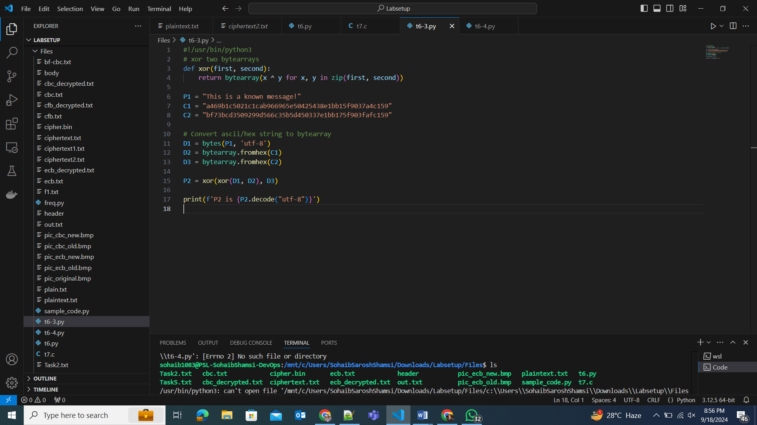
6.3:
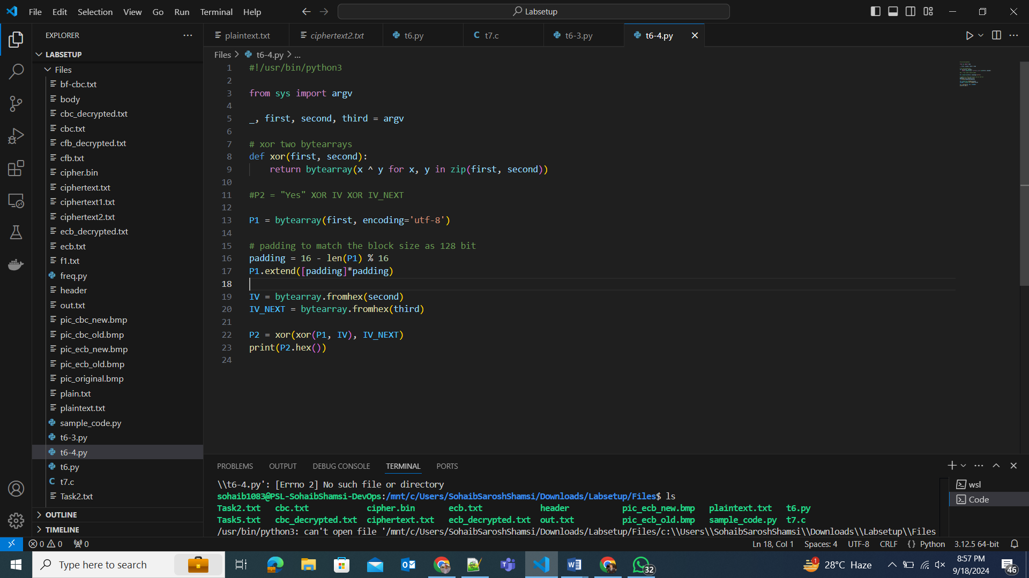

After obtaining the cipher text C2, we extracted the first block (16 bytes) of this cipher text. We then compared it to the original cipher text C1. If the blocks match, it confirms that the plaintext P1 used to generate P2 is indeed correct. As the blocks matched, the Bob’s message was “Yes”.
Task 7:
We wrote a script in C language to determine what the key was out of the word list, given the cipher text, plain text and IV. We encrypted the plain text with each word using the openssl library’s functions, applying the aes-128-cbc cipher mode in the word list and compared the result to the cipher text. If the encrypted text and the cipher text matched, that meant that that word was the key. The key turned out to by ‘Syracuse’.


